Zonta Meeting: Areas 1 & 3
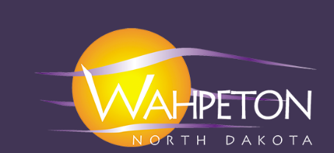
Wahpeton, ND

Welcome to Wahpeton
Friday April 11
5:30 Arrive at Prantes. Dinner will be Prantes with a variety of other menu items (on your own). group activity starts at 7 pm
Saturday April 12 Travelodge & Prantes
Breakfast at hotel
8:45-9:00 Welcome from Host Club, Area Directors, Introductions
9:00-9:20 Governor’s Report
9:20—9:40 Zonta International Foundation Report
9:40-10:00 Z1 Core Values Power Point
10:00-10:15 Break and Baskets
10:15- 10:45 Round Tables -- Energizing Member Engagement, Service/Advocacy, or Fundraising Ideas
10:45-11:00 Round Table Reports
11:00-noon Featured Speaker Financial Planning
12:00 Lunch/Networking
1:00-1:15 Break/Basket Auction/Marketplace
1:15 -2:30 Featured Speaker Self-Care Alicia Blaufuss, PA
2:30-2:45 Break
2:45-3:15 Workshop Wrap-Up & Basket Results
Zonta International is a leading global organization of individuals working together to build a better world for women and girls.

REGISTRATION FORM
April 11-12 2025
Hotel Location: Travelodge
Area Meeting Meeting Space: Prantes

Conference Sessions (Mark the events that you will be attending)
□ Friday Social Event only 5:30 – 7 PM ………………………………………………….…… Dinner at Prantes (on own payment)
□ Friday Painting Event 7 -9 PM ……………………………………………………………..…….$30/person
□ Saturday Conference (includes Lunch & Snacks) ……………………….……….$50/person

*Please print and complete this form and send along with a check payable to Zonta Club of Breckenridge – Wahpeton.
Name _________________________________________________________________________
Club _________________________________________________________________________
Address _________________________________________________________________________
City ________________________________ STATE ______________ ZIP _______________
Amount Due/Paid _____$50 registration ______$30 Friday event TOTAL $ ______
Make checks payable to_______ RETURN BY March 31
No refunds after April 4
Please note any food allergies/special accommodations needed: _________________________________
______________________________________________________________________________________
______________________________________________________________________________________
A block of hotel rooms has been reserved under the group name: Zonta
Group Rate: $154 / night 2 Bed per Room Standard– Please make reservations by February 28
Hotel Info: Travelodge 995 21st Ave N Wahpeton ND 58075 (701) 484-0378

Send Registration Info to:
Jessica Gilsrud 663 Richland St. Wahpeton, ND 58075

Please return registration info by March 31.

